**Function**

1.Just Print(Function এর মধ্যে টাইপ দিতে হয় না।)

<?php

*//no need to specify variable type*

    function myFunction($width,$height){

        echo $width*$height."<br>";

    }

    myFunction(10,20);

?>

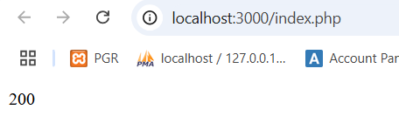

2.value return

<?php

*//no need to specify variable type*

*//value return*

    function areaRectangle($width,$height){

        return $width*$height;

    }

    echo "Area is ".areaRectangle(10,20);

?>

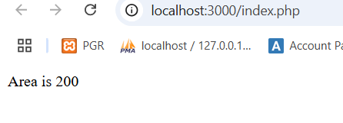

3.Array Return

<?php

*//no need to specify variable type*

*//value return*

    function areaRectangle(){

        return ["name"=>"utsab","age"=>20];

    }

    $personData=areaRectangle();

    print_r($personData);

?>

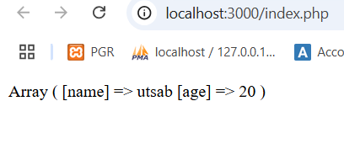

4.Built in function

<?php

    $name="utsab roy";

    echo strlen($name);

?>

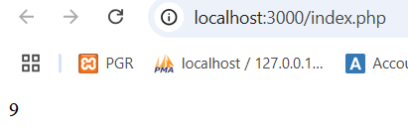

5.Default parameter

এখানে ‍দুটি argument pass না করে একটা pass করলে ডিফল্ট argument কাজ করবে।দুটি argument pass ডিফল্ট কাজ করবে না।

<?php

    function sum($a,$b=10){

        return $a+$b;

    }

    echo"Sum is ".sum(20,20)."<br>";

    echo "Sum is ".sum(15);

?>

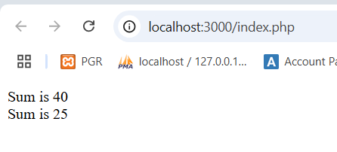

6.Single Type Declaration

(এক্ষেত্রে parameter এ টাইপ দেয়া যায় এবং return type ও দেয়া যায়।)

<?php

*//we can give data type in method and give return type*

function square(int $number): int {

    return $number * $number;

}

echo square(4); *// Outputs: 16*

?>

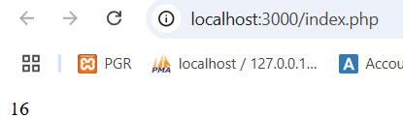

7.Strict Types

(এখানে int এর জায়গায় string পাঠালেও কাজ করতেছে কিন্তু আমরা চাচ্ছি datatype match না হলে এরর দেখাবে এজন্য string type enable করতে হয়।)

<?php

*//we can give data type in method and give return type*

function square(int $number): int {

    return $number * $number;

}

echo square("10"); *// Outputs: 16*

?>

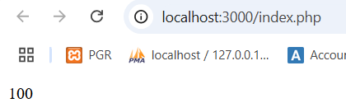

<?php

declare(strict_types=1);

*//we can give data type in method and give return type*

function square(int $number): int {

    return $number * $number;

}

echo square("10"); *// Outputs: 16*

?>

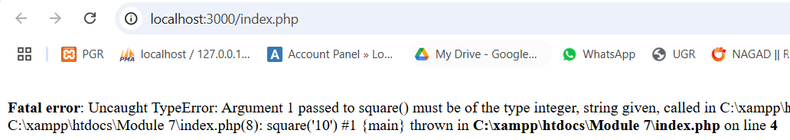

8.Multiple Type Hint

এক্ষেত্রে একটা argument এ একাধিক টাইপ দিয়ে দিতে পারি অর্থাত যে কোন টাইপ match করলে রিসিভ হবে ডাটা।(তবে এটা php 8 এ সাপোর্ট করবে।)

<?php

function add(int|float $a, int|float $b): int|float {

    return $a + $b;

}

echo add(5, 3.5);   *// Outputs: 8.5*

echo add(4, 2);     *// Outputs: 6*

?>

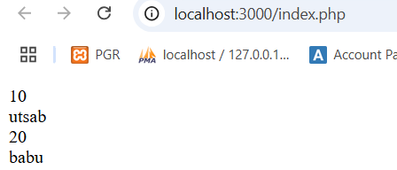

9. Variadic Function

(এখানে একসাথে একাধিক value recive হয়।)

<?php

*//we can recive multiple data*

    function allData(...$values){

        foreach($values as $value){

            echo $value."<br>";

        }

    }

    allData(10,"utsab",20,"babu")

?>

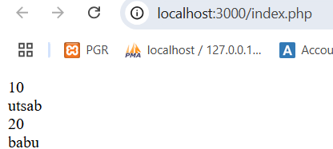

<?php

    function greet($greeting,...$names){

        foreach($names as $name){

            echo "$greeting , $name<br>";

        }

    }

    greet("Hellow","utsab","babu","sebak");

?>

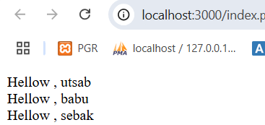

**10. anonymous functions** or **closures**.

**() Function define**

**() Function call**

**এই ফাংশন পেইজ যখন লোড হবে তখন execute হবে।**

<?php

(function() {

*// Function code*

})();

?>

<?php

    (function() {

        echo"Hellow world!";

    })();

?>

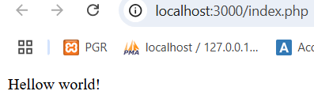

//value pass করতে পারি anonymous function এ।

<?php

    $add=function($a,$b){

        return $a+$b;

    };

    echo $add(10,20);

?>

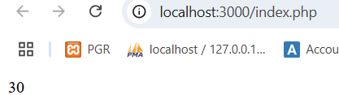

**LOOP**

**FOR LOOP**

<?php

    for($i=1;$i<=3;$i++){

        echo"Iteration $i<br>";

    }

?>

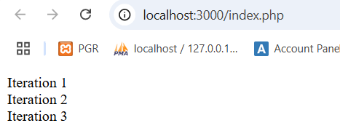

**WHILE LOOP**

<?php

    $i=1;

    while($i<=2){

        echo "Iteration $i <br>";

        $i++;

    }

?>

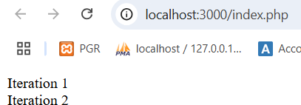

**DO-WHILE LOOP**

<?php

    $i=1;

    do{

        echo"Iteration $i<br>";

        $i++;

    }while($i<=2);

?>

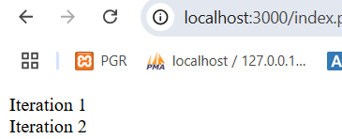

**Array**

**Indexed Arrays**: Use numeric indices (either default or custom).

(এখানে ইনডেক্স 0,১,… থাকে)

Indexed array access করা যাবে for loop এবং foreach loop দিয়ে।

<?php

*//index array access by for loop and foreach loop*

    $indexed_array=[10,20,30,"utsab","babu"];

*//for loop*

    for($i=0;$i<count($indexed_array);$i++){

        echo "Index=$i value= $indexed_array[$i] <br>";

    }

*//foreach*

    foreach($indexed_array as $value){

        echo "value=$value<br>";

    }

?>

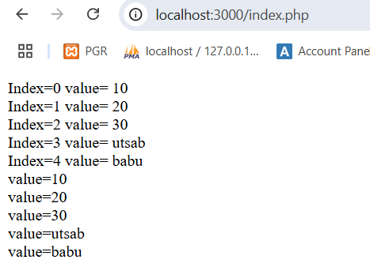

**Associative Array:** Use descriptive keys (either strings or integers) to associate with values.

[key value থাকবে এবং এটা foreach লুপ দিয়ে access করতে হবে।]

<?php

    $person=[

        "name"=>"utsab",

        "id"=>154061,

        "result"=>3.41

    ];

    foreach($person as $key=>$value){

        echo "$key===$value<br>";

    }

?>

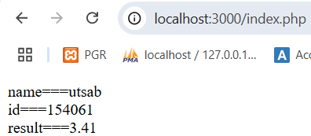

**Memory structure**

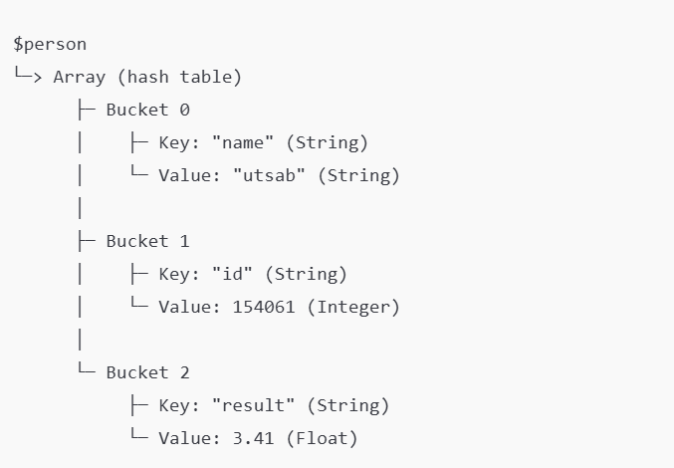

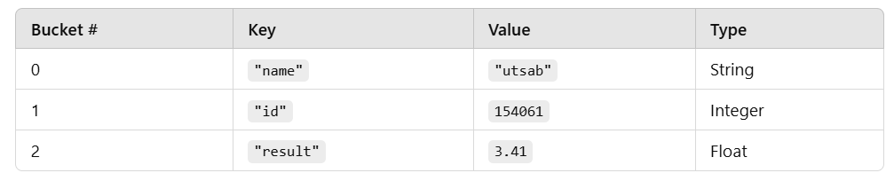

<?php

$students = [

    "student1" => [

        "name" => "Utsab",

        "subjects" => [

            "Math" => "A",

            "English" => "B+",

            "Science" => "A-"

        ]

    ],

    "student2" => [

        "name" => "Babu",

        "subjects" => [

            "Math" => "B",

            "English" => "A",

            "Science" => "B+"

        ]

    ],

    "student3" => [

        "name" => "Alice",

        "subjects" => [

            "Math" => "A-",

            "English" => "B",

            "Science" => "A"

        ]

    ]

];

*// Displaying data with foreach*

foreach ($students as $studentKey => $studentInfo) {

    echo "Student ID: $studentKey<br>";

    echo "Name: " . $studentInfo["name"] . "<br>";

    echo "Subjects and Grades:<br>";

    foreach ($studentInfo["subjects"] as $subject => $grade) {

        echo "- $subject: $grade<br>";

    }

    echo "<br>";

}

?>

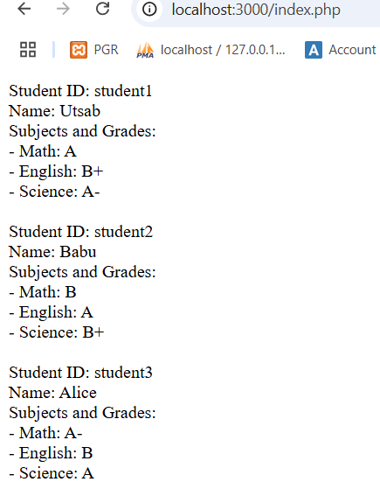

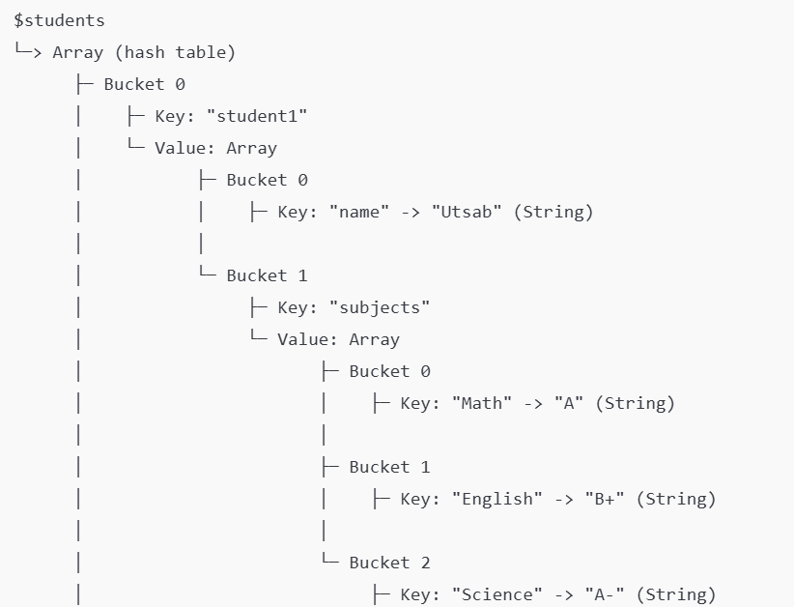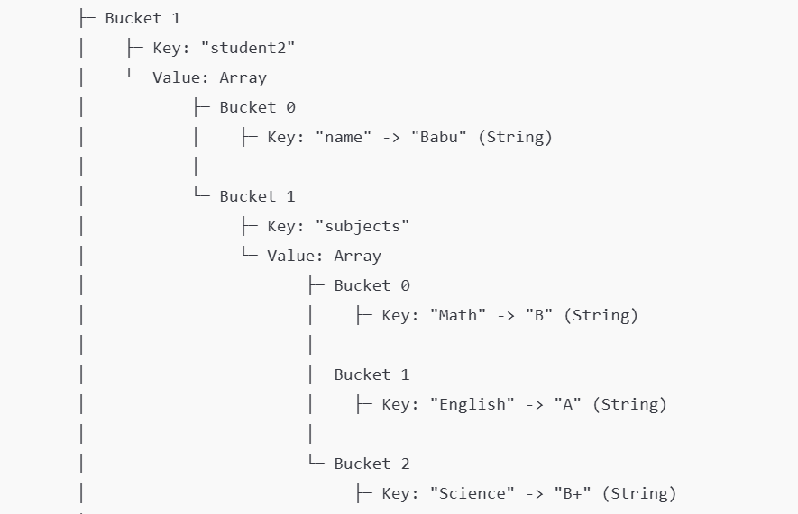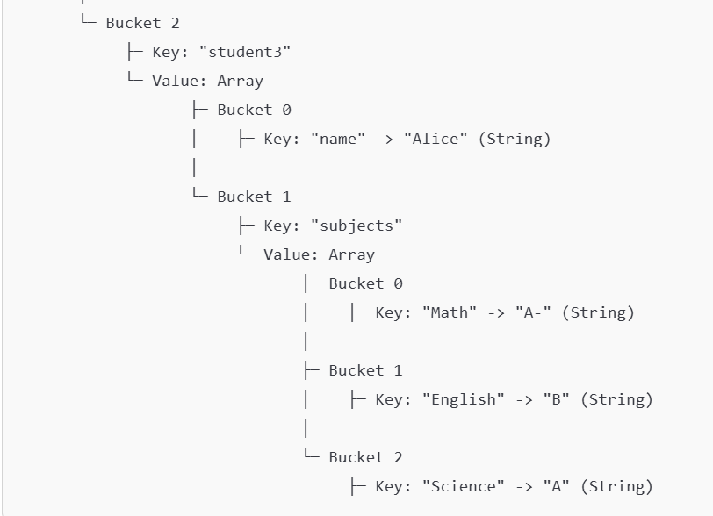

3 loop

<?php

    $students=[

        "student1"=>[

            "name"=>"utsab",

            "subjects"=>[

                "math"=>"A+",

                "english"=>"B+",

                "science"=>"A"

            ]

        ],

        "student2"=>[

            "name"=>"babu",

            "subjects"=>[

                "math"=>"A",

                "english"=>"A-",

                "science"=>"Fail"

            ]

        ]

    ];

    foreach($students as $singleStudent=>$studentInfos){

        echo"Student Id $singleStudent <br>";

        foreach($studentInfos as $studentInfoKey=>$studentInfoValue){

            if($studentInfoKey=='subjects'){

                foreach($studentInfoValue as $singleSubject=>$singleSubjectResult){

                    echo"$singleSubject $singleSubjectResult<br>";

                }

            }else{

                echo" $studentInfoKey $studentInfoValue<br>";

            }

        }

        echo"<br><br>";

    }

?>

